# **CTF Topic: Java Script Injection**

# **Introduction**

We will be running a penetration test in a demo juice shop’s website demonstrating one of its vulnerabilities, In this type of attack the attacker sends/injects a malicious code inside the application to make it run an unintended process, it can be quite easy to do. Here I am going to inject a line of javascript code into the website to demonstrate how you can do it .

# **Scenario**

You are required to perform a javascript injection in the Owasp juice shop website which you have hosted and perform a basic

# **Begin**

Access the wasp juice shop and inter the javascript payload as required

# **Question**

# **Flag 1 :** What command did you use to send alert message

# **Answer :** Alert

# **Flag 2 :** Which port is the website being hosted on

# **Answer :** 3000

# **Hint**

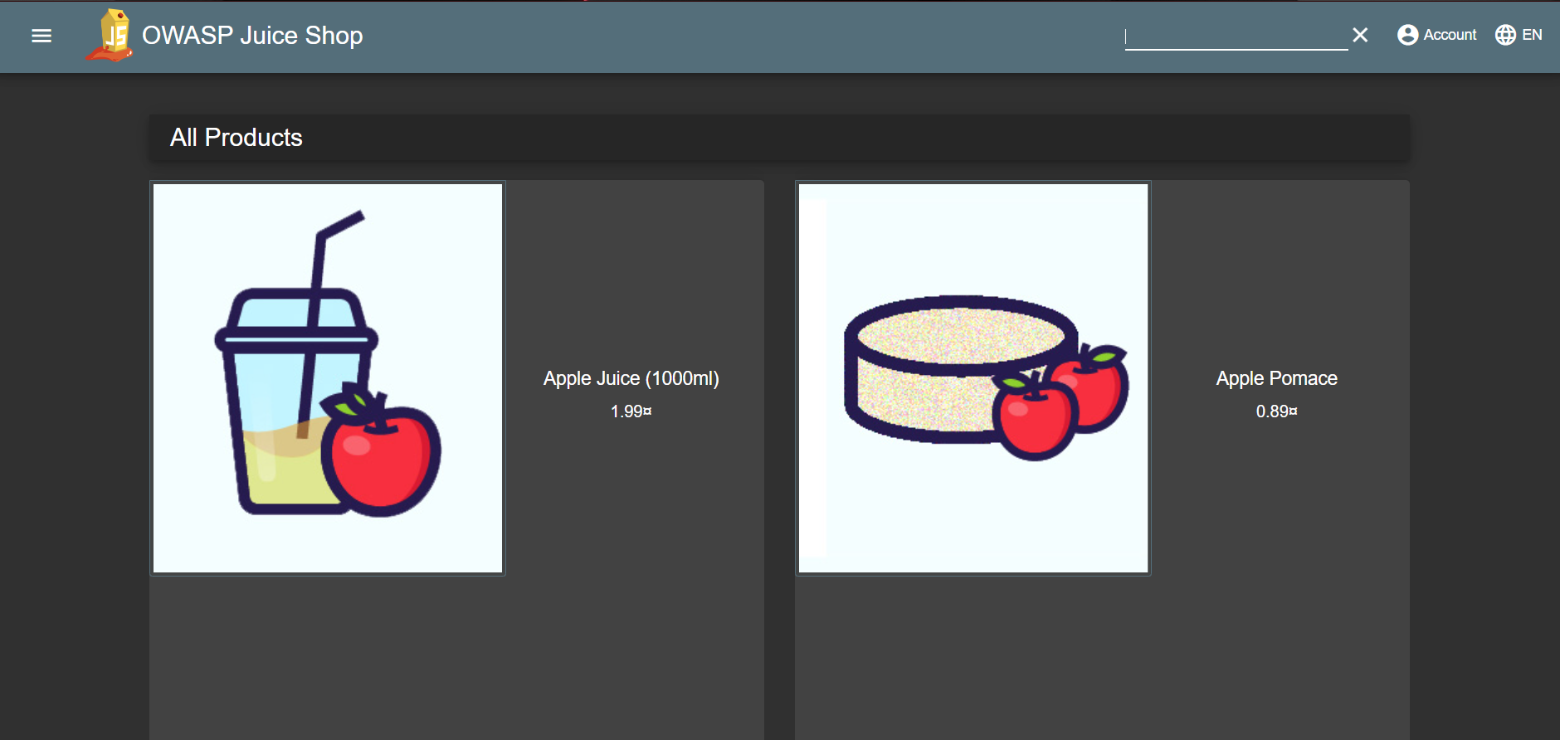



<iframe src="javascript:alert('This is a type of injection attack')">

